NVIDIA英伟达校招持续火热进行中！
第二批笔试时间已经确定！
笔试时间：10月12日 周五 19:00 统一开考
笔试形式：在线笔试
笔试人群：投递此次笔试岗位的候选人，以第一志愿为主；接受调剂职位的候选人。（第二批笔试名单：截止至10月11日周四下午3:00之前投递的候选人）
仍在火热招聘中的岗位（标绿岗位为此次笔试的岗位）：
软件 - 深度学习/人工智能类：
- AI Developer Technology Engineer – 北京、上海、深圳
- Autonomous Driving System Engineer – 上海
- Deep Learning Performance Architect -上海
- Deep Learning Engineer for Self-driving Car – 上海
- Deep Learning Solution Architect – 北京
- High Performance Computing Research Engineer – 北京、上海、深圳
- Machine Learning Algorithm Engineer – 北京、上海、深圳
软件 - C/C++类：
- Graphics Developer Technology Engineer - 上海
- GPU Profiling Engineer - 上海
- Graphics C++ Engineer -上海
- Video/CPU Architect -上海
软件 - 系统开发类：
- Embedded System Software Engineer –深圳
- Android System Software Engineer – 北京
软件 - Web类：
- Web Full-Stack Engineer - AI Cloud – 上海
- Web Services Software Engineer – 深圳
- Web Application Engineer – 上海
硬件 - IC Level：
- ASIC Design/Verification Engineer – 上海
- ASIC Engineer-SOC - 上海
- ASIC Physical Design Engineer -上海
- ASIC-PD Flow Automation Developer - 上海
- Hardware Engineer – 上海
- VLSI Physical Design Engineer -上海
- Physical Design CAD Engineer – 上海
- DFT Engineer - 上海
- Power Methodology/Analysis Engineer -上海
硬件 - Board Level：
- PCB Design Engineer -深圳
- Thermal engineer - 深圳

我们的校招持续火热进行中，所有官网可投递职位均在招聘中，欢迎大家投递！期待面试见！
更多职位详情，请见校招官网：
http://campus.51job.com/nvidia/ （电脑版）
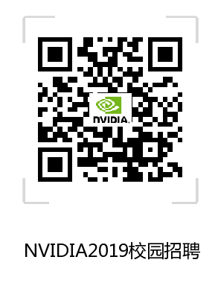
（手机版）点击全文：链接：http://companyads.51job.com/companyads/social/m/NVIDIA/index.html

